Assignment 4

Heap Data Structures: Implementation, Analysis, and Applications

Priyanka Dhungana
University of the Cumberlands
Algorithms and Data Structures
November 6, 2026

Introduction

Choosing the right data structure can make a major difference in how efficiently a program processes information. This assignment focuses on implementing Heapsort and a max-heap priority queue in Python. Heapsort was compared with Quicksort and Merge Sort, and the priority queue was used to simulate task scheduling. The goal was to connect algorithm theory with practical testing results (Cormen et al., 2022).

Heapsort Implementation and Design

Heapsort uses a binary heap to arrange values. A max-heap was used, meaning each parent is at least as large as its children. First, the program builds the heap. It then swaps the largest value at the root with the last unsorted value and restores the heap property.

This process continues until the array is sorted. The Python implementation uses heapify() to maintain the heap and heapsort() to sort the array. The program was tested with empty arrays, single values, duplicate values, sorted inputs, reverse-sorted inputs, and ordinary arrays. All tests returned the expected sorted results.

Figure 1

Heapsort Implementation and Correctness Testing

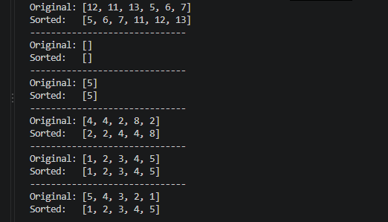

Time and Space Complexity Analysis
Building a max-heap takes O(n) time because most nodes are near the bottom and need little adjustment. During sorting, the largest value is removed repeatedly, and each heap adjustment takes at most O(log n) time. Together, the running time is O(n) + O(n log n) = O(n log n). The tighter bound is Θ(n log n) in the best, average, and worst cases (Cormen et al., 2022).
Heapsort sorts in place. With the iterative heapify method used in this implementation, it needs O(1) auxiliary space. Its main costs are comparisons, swaps, and restoring the heap after each extraction. This helps explain why a sorting algorithm with strong theoretical guarantees may still run more slowly than another algorithm in a particular experiment (Sedgewick & Wayne, 2011).
Performance Comparison
Heapsort, randomized Quicksort with three-way partitioning, and Merge Sort were compared using sorted, reverse-sorted, and random arrays of 1,000, 5,000, and 10,000 values. Python’s time.perf_counter() function measured execution time, and each result in Table 1 is the average of five runs. All algorithms were checked for correct sorting output.
Table 1
Execution Time Comparison of Sorting Algorithms (Seconds)
Dataset Size | Data Type | Heapsort | Quicksort | Merge Sort
1,000 | Sorted | 0.002273 | 0.003583 | 0.003725
1,000 | Reverse | 0.007752 | 0.005578 | 0.003442
1,000 | Random | 0.007064 | 0.002704 | 0.004394
5,000 | Sorted | 0.022133 | 0.022608 | 0.040991
5,000 | Reverse | 0.023812 | 0.013694 | 0.012503
5,000 | Random | 0.057611 | 0.016206 | 0.017518
10,000 | Sorted | 0.037779 | 0.027230 | 0.031581
10,000 | Reverse | 0.070866 | 0.065866 | 0.027395
10,000 | Random | 0.049797 | 0.032257 | 0.033306
Note. Execution times represent the average of five runs for each algorithm and dataset combination.
Discussion of Sorting Results
The fastest algorithm depended on the type and size of the input. For 10,000 random values, Quicksort was fastest at 0.032257 seconds, followed closely by Merge Sort at 0.033306 seconds. Heapsort took 0.049797 seconds. Merge Sort performed particularly well on reverse-sorted inputs. For 10,000 values, it took 0.027395 seconds, compared with 0.065866 seconds for Quicksort and 0.070866 seconds for Heapsort.
Heapsort was fastest for the sorted array of 1,000 values. These differences do not contradict the complexity analysis: Heapsort and Merge Sort have Θ(n log n) running time, while randomized Quicksort has expected Θ(n log n) time (Cormen et al., 2022). Implementation choices, recursion, memory access, and system conditions can all influence measured speed. Larger datasets and more controlled tests would make the comparison more reliable.
Figure 2
Sorting Performance for 1,000 Elements
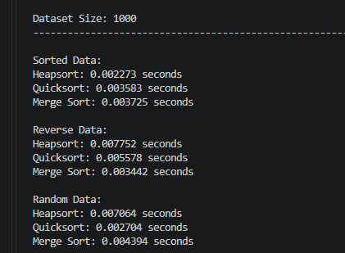

Figure 3
Sorting Performance for 5,000 Elements
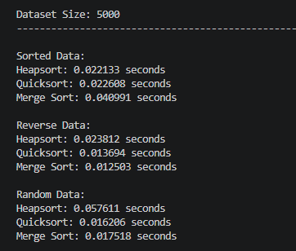
Figure 4
Sorting Performance for 10,000 Elements

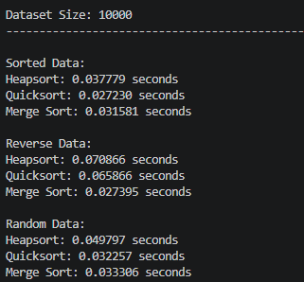

Priority Queue Implementation and Design
The second part of the assignment involved a priority queue built with a binary max-heap. Instead of processing tasks in arrival order, it selects the available task with the highest numerical priority. A Python list stores the heap, allowing the program to locate a node’s children at 2i + 1 and 2i + 2 and its parent at (i − 1) // 2.
Each Task object contains an ID, priority, arrival time, and deadline. The PriorityQueue class supports inserting tasks, removing the highest-priority task, updating priorities, and checking whether the queue is empty. A dictionary tracks task positions so the program can locate a task efficiently before changing its priority.
Priority Queue Complexity
Insertion, extraction, and priority updates each take O(log n) time in the worst case because a task may move through the height of the heap. Finding a task using the position dictionary takes expected O(1) time. Checking whether the queue is empty takes O(1), while the heap and dictionary together require O(n) storage.
Table 2
Time Complexity of Priority Queue Operations
Operation | Time Complexity
Insert task | O(log n)
Extract maximum | O(log n)
Increase priority | O(log n)
Decrease priority | O(log n)
Check if empty | O(1)
The queue was tested by inserting four tasks, raising one priority, lowering another, and extracting tasks until the queue was empty. The output followed the expected priority order.
Figure 5
Priority Queue Implementation and Testing

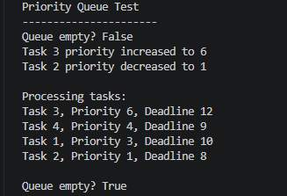

Task Scheduler Simulation
To demonstrate a practical use of the priority queue, a simple non-preemptive task scheduler was developed. Tasks entered the queue based on arrival time, and the scheduler selected the highest-priority available task. Each task required one time unit to complete. The simulation included eight tasks with different priorities, arrival times, and deadlines. Waiting time, turnaround time, and deadline success were recorded.
Table 3
Task Scheduler Performance Summary
Performance Metric | Result
Total tasks completed | 8
Average waiting time | 1.25 time units
Average turnaround time | 2.25 time units
Tasks meeting deadlines | 7
Missed deadlines | 1
Deadline success rate | 87.5%
Figure 6
Task Scheduler Simulation and Performance Results

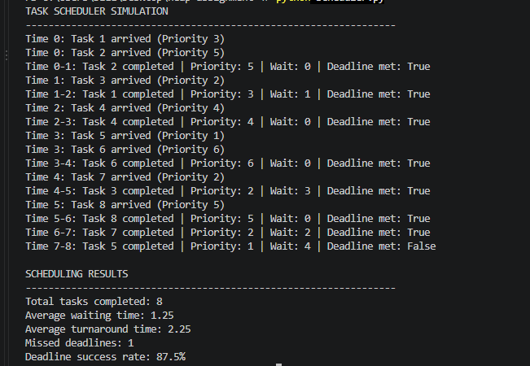

Analysis of Scheduling Results
All eight tasks completed, with seven meeting their deadlines. Average waiting time was 1.25 time units, and turnaround time was 2.25 units. Task 5 missed its deadline after waiting four time units due to its low priority. This shows that priority scheduling favors urgent tasks but can delay less important ones. Priority aging or deadline-based scheduling could help reduce delays. Real-world scheduling is more complex because tasks may have different durations and interruptions (Silberschatz et al., 2018).
Real-World Applications
Heaps are useful when a program needs predictable sorting or quick access to the highest-priority item. Heapsort is suitable when worst-case O(n log n) time and low auxiliary memory usage are important. Priority queues can help operating systems schedule jobs, servers process urgent requests, and event-driven simulations handle scheduled events. The assignment demonstrates how the same underlying heap structure can support both sorting and scheduling.
Conclusion
The implementation of Heapsort and a priority queue demonstrated how heap operations work in practical applications. Sorting experiments showed that strong time-complexity guarantees do not always produce the fastest measured execution. The scheduling simulation also showed that efficiently choosing high-priority tasks can delay less urgent work. Overall, the project highlighted the importance of considering theoretical efficiency and practical trade-offs when choosing data structures.
References
Cormen, T. H., Leiserson, C. E., Rivest, R. L., & Stein, C. (2022). Introduction to algorithms (4th ed.). MIT Press. https://mitpress.mit.edu/9780262046305/introduction-to-algorithms/
Sedgewick, R., & Wayne, K. (2011). Algorithms (4th ed.). Addison-Wesley Professional. https://www.informit.com/store/algorithms-9780132762564
Silberschatz, A., Galvin, P. B., & Gagne, G. (2018). Operating system concepts (10th ed.). Wiley. https://www.wiley.com/en-us/operating-system-concepts-10th-edition-p-9781119320913

